**Experiment no - 03**

**Aim:** Write a program to construct DFA using given regular expression.

**Description:**

Given a string S, the task is to design a Deterministic Finite Automata (DFA) for accepting the language L = C (A + B)+. If the given string is accepted by DFA, then print “Yes”. Otherwise, print “No”.

Examples:

Input: S = “CABABABAB”  
Output: Yes  
Explanation: The given string is of the form C(A + B)+ as the first character is C and it is followed by A or B.

Input: S = “ACCBBCCA”  
Output: No

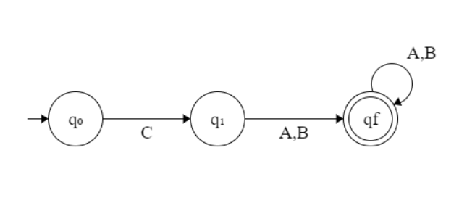

* If the given string is of length less than equal to 1, then print “No”.
* If the first character is always C, then traverse the remaining string and check if any of the characters is A or B.
* If there exists any character other than A or B while traversing in the above step, then print “No”.
* Otherwise, print “Yes”.
* Below is the implementation of the above approach:

**Program:**

***#Program to Construct DFA using REGEX*****def** DFA(str, N):  
 *# If n <= 1, then prNo* **if** (N <= 1):  
 print(**"No"**)  
 **return** *# To count the matched characters* count = 0  
 *# Check if the first character is C* **if** (str[0] == **'C'**):  
 count += 1  
 *# Traverse the rest of string* **for** i **in** range(1, N):  
  
 *# If character is A or B,  
 # increment count by 1* **if** (str[i] == **'A' or** str[i] == **'B'**):  
 count += 1  
 **else**:  
 **break  
 else**:  
 *# If the first character  
 # is not C, pr-1* print(**"No"**)  
 **return** *# If all characters matches* **if** (count == N):  
 print(**"Yes"**)  
 **else**:  
 print(**"No"**)  
*# Driver Code***if** __name__ == **'__main__'**:  
 str = **"CAABBAAB"** N = len(str)  
 DFA(str, N)

**OUTPUT:**

**Given String as : “CAABBAAB”**

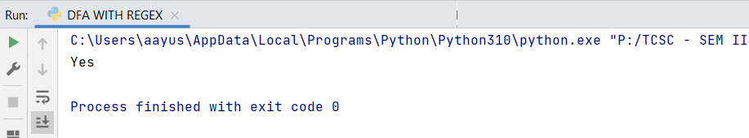

**Given String as : “ACCBBCCA”**

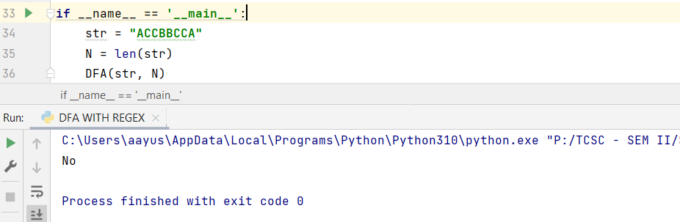

**Conclusion :** The given string is accepted by DFA as “CAABBAAB”